**Installing RT-Thread Studio for the**

**WCH CH32V307V Development Board**

**Last updated:** 8/9/2022

**Software:** Windows 10 Home (21H2)

RT-Thread Studio 2.2.5.0

WCH CH32V307V-R1 1.0.8 (2022-05-23) SDK

1) Navigate to the **RT-Thread website**.

<https://www.rt-thread.io/download.html?download=Studio>

2) Click on the RT-Thread Studio “**Free Download**” button.

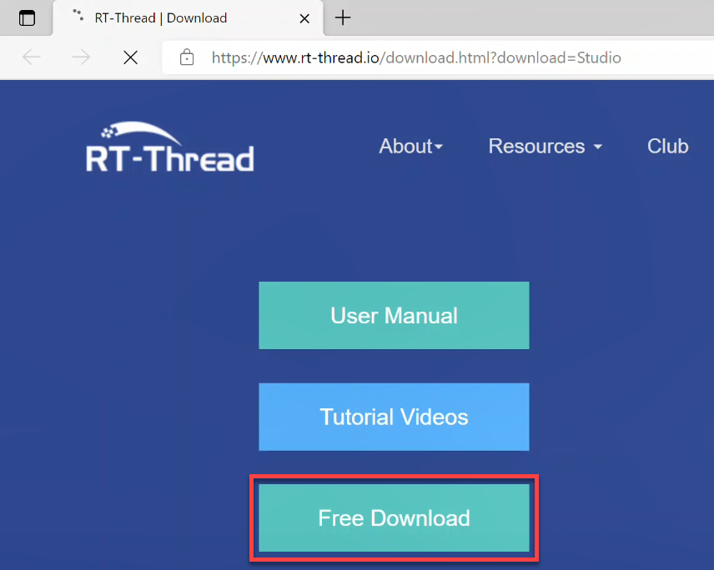

3) Wait for the download to finish.

4) If needed, click on the **drop-down** menu and select “**Keep**”.

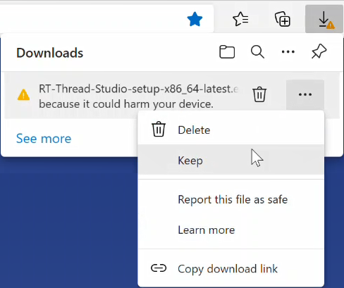

5) If needed, click on “**Show more**”, then click “**Keep Anyway**”.

|  |  |
| --- | --- |
|  |  |

6) Open the **Downloads** folder.

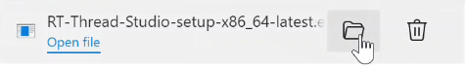

7) **Double click** on the installer file “**RT-Thread-Studio-setup-x86_64-latest.exe**”.

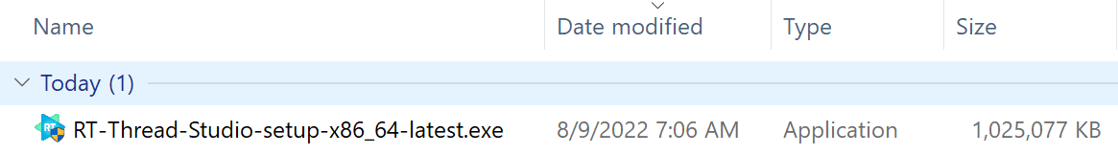

8) If prompted, click on “**More info**”, and then “**Run anyway**”.

|  |  |
| --- | --- |
|  |  |

9) Click on “**Next**”.

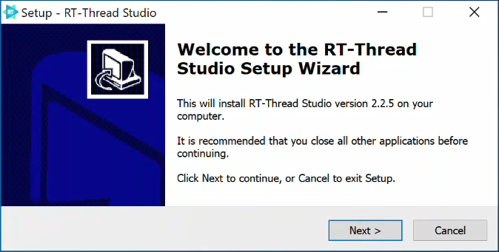

10) **Accept** the license agreement and then click **Next**.

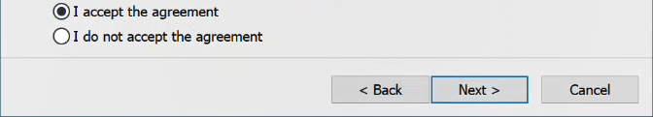

11) Confirm the **Destination Location** and then click **Next**.

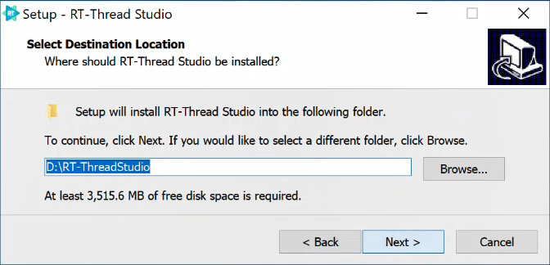

12) Confirm the **Start Menu** folder and then click **Next**.

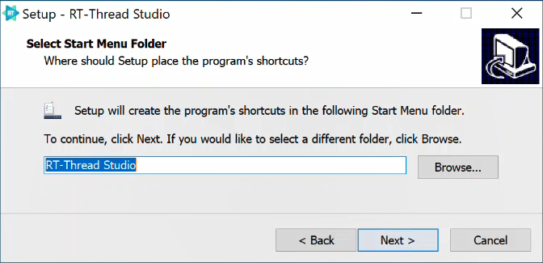

13) Click **Install**.

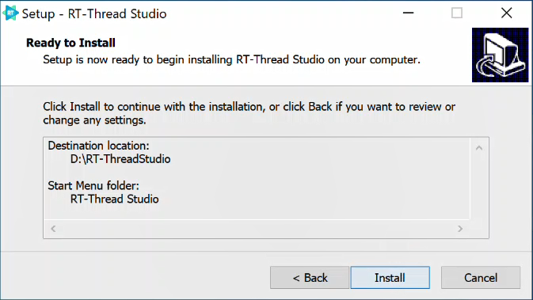

14) **Wait** for the program to install (this can take a while). Then click “**Finish**”.

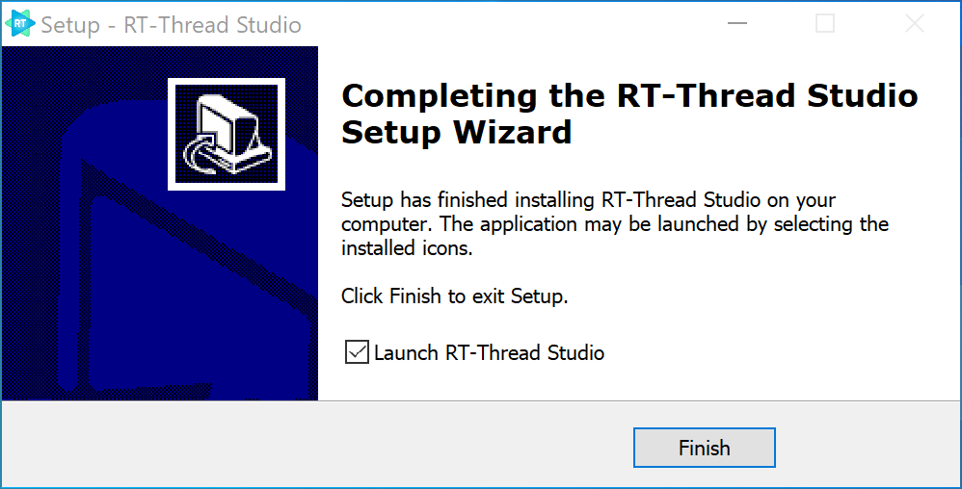

15) If “**Launch RT-Thread Studio**” was selected. The application will open. It might take a while to load the first time.

16) Close the “**Tip of the Day**”. Optionally unselect “**Show on Start**”.

17) Click on “**Create RT-Thread Project**”.

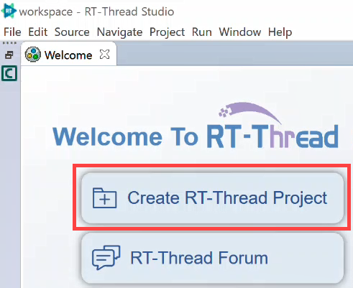

18) Type in a **Project name**. Note: They cannot contain spaces. Select “**Base on board**”. Open the drop-down and select “**add more…**”

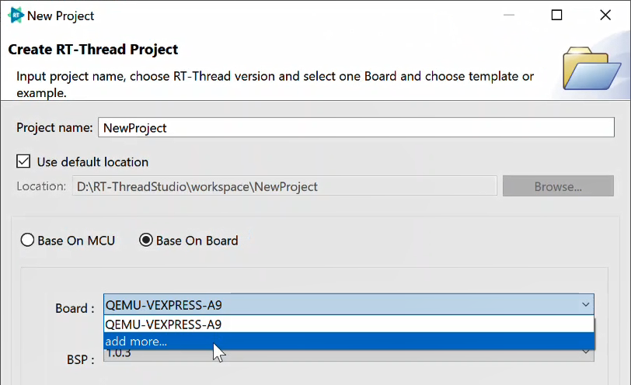

19) In the RT-Thread SDK Manager, navigate to **Board_Support_Packages** > **WCH** > **CH32V307V-R1**. Select the **latest package**.

20) Click on “**Install 1 package**”

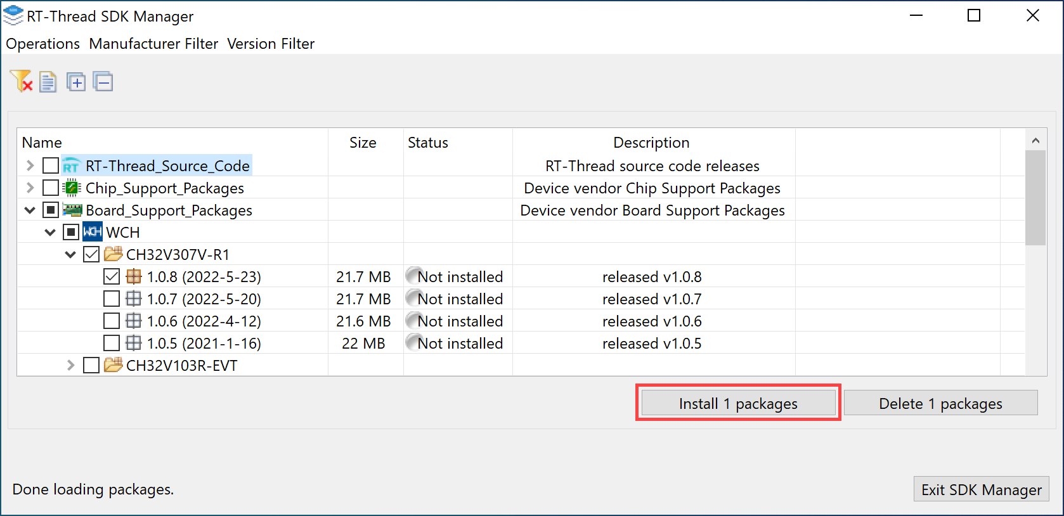

20) Wait for the package to install. This may take a while.

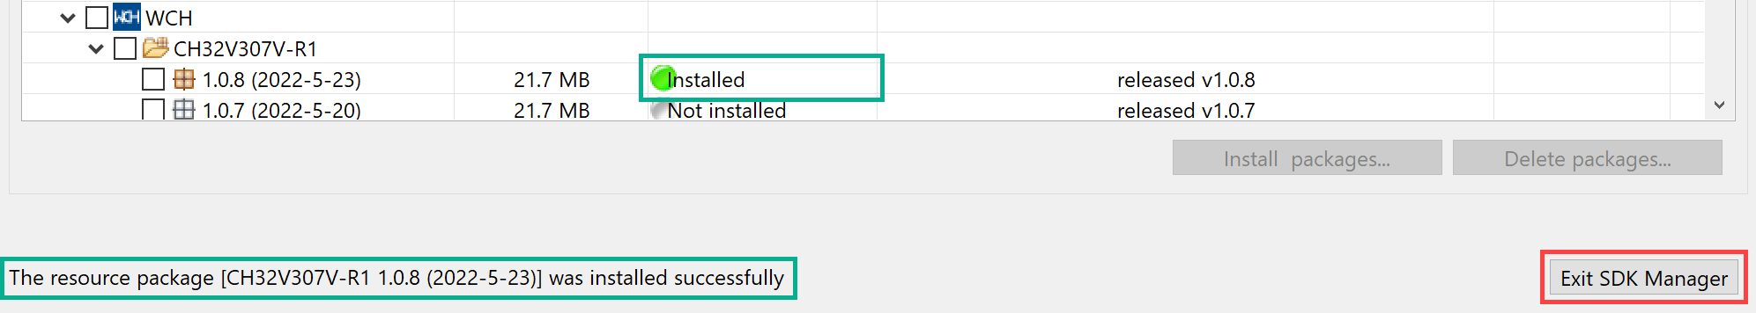

21) If the project wizard closes, open the **File menu**, select **New** and then click on “**RT-Thread Project**”.

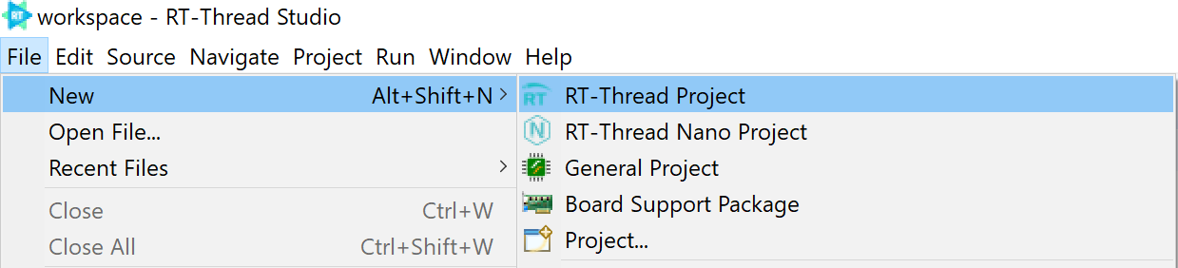

22) Select “**Base on Board**” and select the “**CH32V301V-R1**”. Then click **Finish**.

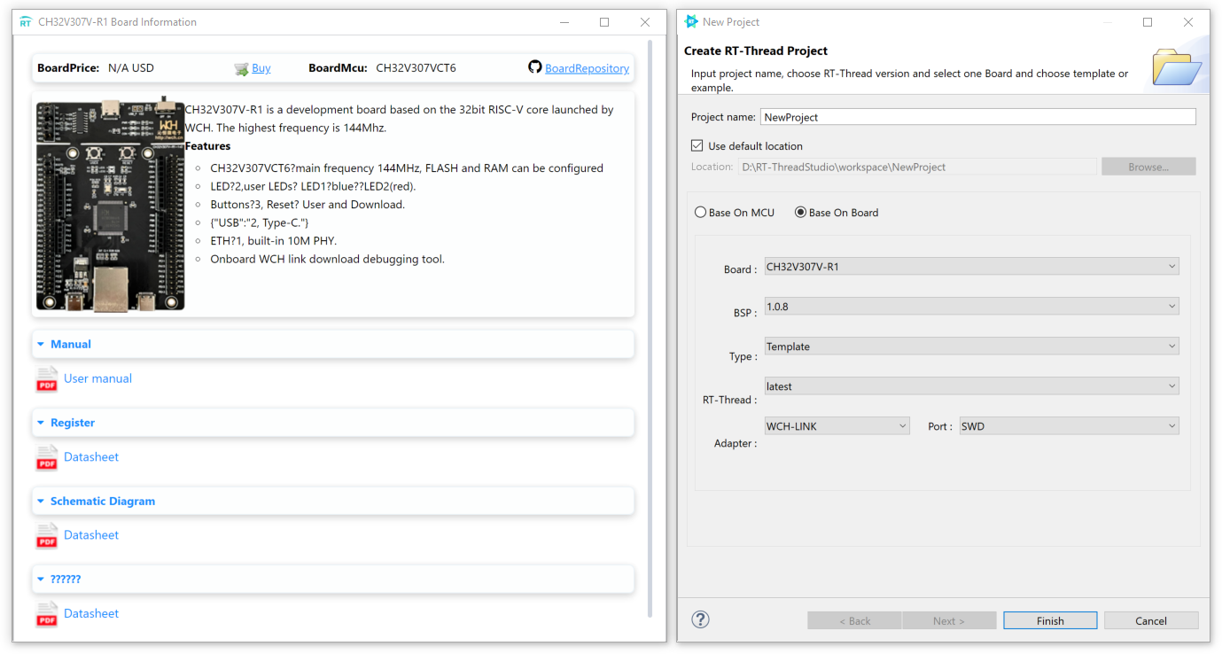

23) Wait for it to create the new RT-Thread project. This may take a while.

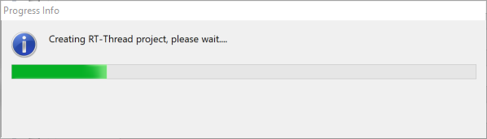

24) The project should appear in the “**Project Explorer**”.

